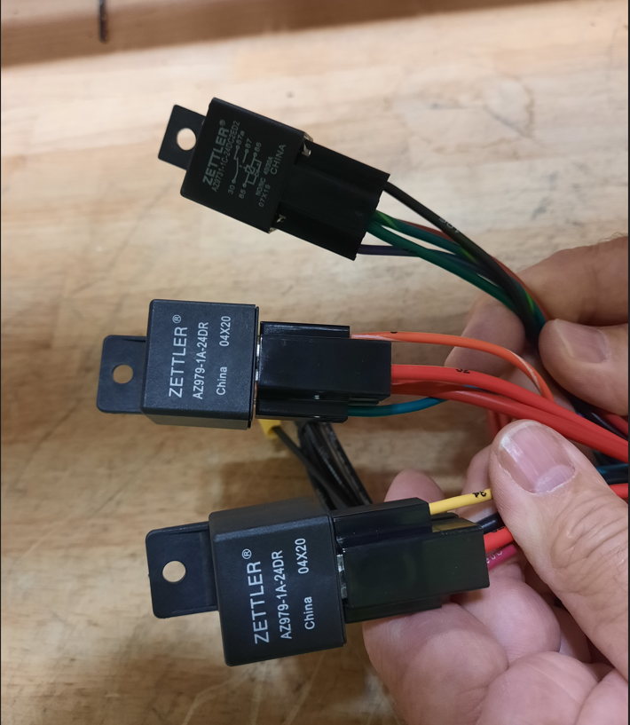
Pad Release
Vacuum Motor
I Drive

